Gõ đầu con vịt: tìm được hài cốt người khổng lồ
Thời buổi nầy cái gì cũng giả hết. Mấy hôm nay trong email người Việt Nam mình loan tin như bươm bướm là tìm được xương người khổng lồ với nhiều hình ảnh. National Geographic chỉ đ1ich danh thủ phạm đã edit hình của họ làm thành tin “dịch vật”
Hình trên có thật, chưa edit. Mấy hình dưới do Worth lấy từ NG rồi thêm thắt edit từ để loan tin phịa.
Bên dưới là bài của National Geographic giải thích và chỉ đích danh “thằng” Worth.
HCD (24-Mar-2010)

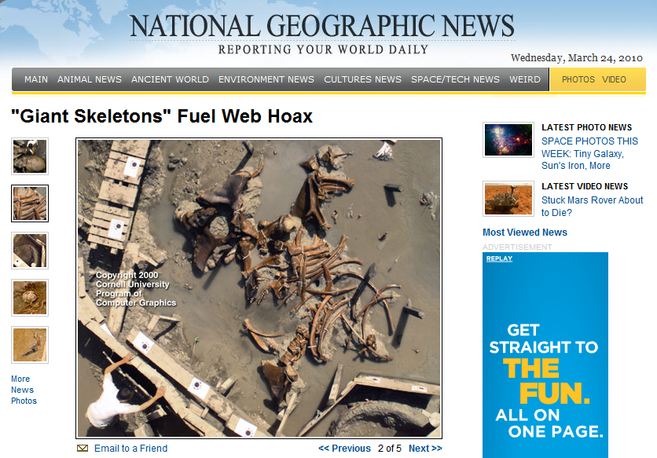

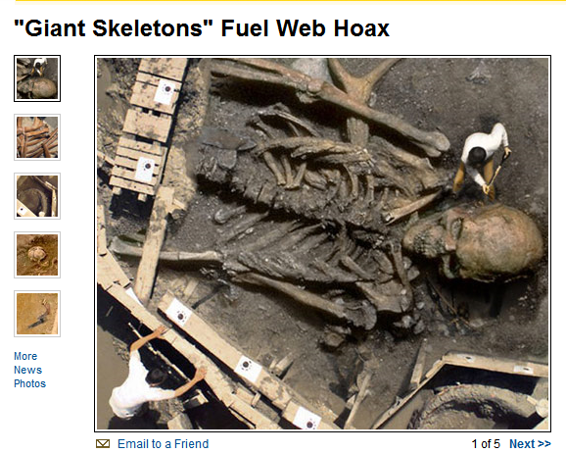

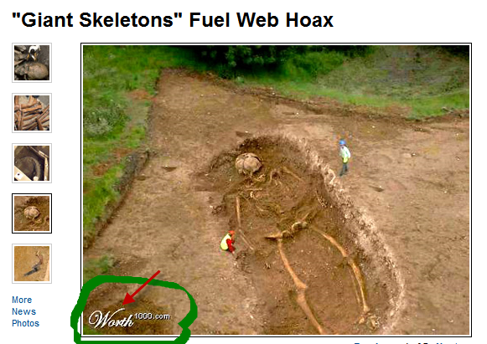
Các bạn thấy chữ Worth do tôi khoanh bên trên không? Cái “thằng” nầy xưa nay chuyên edit hình của thiên hạ giả làm Chúa Làm Phật làm ma làm quỉ. Nhiều webpage tôi giáo vào đó lấy ra để mà phỉnh gạt dân chúng, mất uy tín quá đi.

Dưới đây là nguyên văn của National Geographic bằng tiếng Anh:
December 14, 2007Since 2004 this doctored image has helped give legs to tall tales of ancient giant humans. (Read full story.)

At least one version of the storypublished in the March 2007 issue of India's Hindu Voice monthly and cited in countless blog entries and emails this yearclaims that a National Geographic Society team helped make the "discovery" in India. (The National Geographic Society owns National Geographic News.)

The picture, however, is an innocent fake.

The image was lifted from Worth1000, a Web site that hosts contests for digital artists. Created by an artist using the alias IronKite, the picture placed third in a 2002 competition titled "Archaeological Anomalies 2," which asked contestants to create a hoax archaeological discovery.µ

Man, this guy gets around!µ said IronKitewho does not want his real name used in this storyafter hearing his work had been used to back up the latest false reports.

Canadian artist IronKite used this mastodon-excavation phototaken in 2000 in Hyde Park, New Yorkas the basis for his entry in an online photo-manipulation contest.

The altered photo lies behind persistent Internet rumors, spread since 2004, of archaeologists unearthing ancient human giants.

IronKite digitally superimposed a human skeleton over the mastodon-dig photo, he told National Geographic News in December 2007.

The artist later added a man holding a shovel. His clothing was re-colored to match that of the man in the above, authentic picture. The goal, IronKite said, was to make the shoveler appear to be part of the excavation team.

Though not used to create the skeleton image on the first page of this gallery, this second authentic photo of a New York State mastodon excavation gives another perspective on the dig that served as the foundation for the digital artwork.

The artwork, in turn, inspired false reports of an ancient-giant discovery.

IronKite, the digital artist, had nothing to do with the subsequent hoax.

To create the photo collage, he said, I kept most of the wood frame from the dig site and replaced most of the muddy dirt with ground from the skeleton picture, using a fuzzy 'brush' to fade the two so no hard lines would be visible."

As if one fake giant skeleton weren't enough, other images across the Internet have bolstered claims of massive human remains.
Like IronKite's image on the first page of this gallery, this image by Anakinnnnµ has been used in blog postings and emails about "discoveries" of ancient behemoths.
Also like IronKite's image, this one originally appeared on Worth1000, a site that hosts competitions for digital artists.
The site's two Archaeological Anomalies contests invited entrants to create a hoax archaeological discovery.
"Be open minded," the contest organizers added, "there are many mysteries buried beneath the earth.µ

This digitally altered picture has been featured widely on blogs debating the existence of ancient giantsspeculation fueled in part by false reports of huge skeletons unearthed in India, Saudi Arabia, and elsewhere.

The image, created by Amaranto,µ appears to be a less than serious attempt at a hoaxnote the huge revolver in the skeleton's hand.

Avi Muchnick runs Worth1000, the Web site that sponsored the photo-manipulation contests that inspired the fake photos in this gallery.

We have thousands of people who regularly create images like these in image-editing tools like Phoenix and Photoshop," Muchnick said. "So it's no surprise to us when some of these images get passed around the Web as authentic depictions of actual events."

