Gõ đầu con vịt đẹt Aspirin
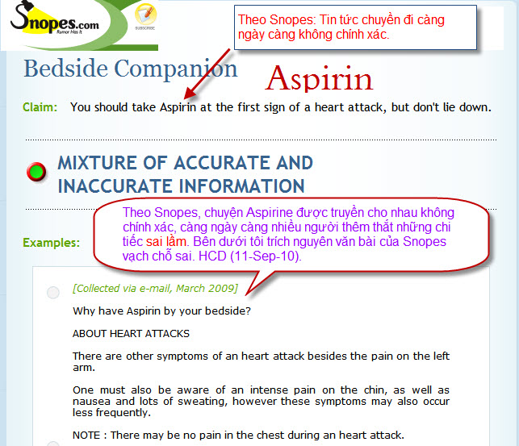
Trong đây có hình, nếu các bạn không thấy hình thì nên dọc attachment.
The original of this seemingly helpful heads-up began circulating on the Internet in March 2009. It has since been modified, with additional bits of advice (such as "unlock the door") thrown in and enhanced by further claims (such as those mentioned in the Variations section above).
The missive is a mixture of both good and bad information. Let's sort the sheep from the goats.
Symptoms of heart attacks aren't as straightforward and easy to spot as many would believe. The American Heart Association says: "Some heart attacks are sudden and intense — the 'movie heart attack,' where no one doubts what's happening. But most heart attacks start slowly, with mild pain or discomfort. Often people affected aren't sure what's wrong and wait too long before getting help."
As explained in far greater detail in our article about heart attack symptoms, while the most common indication of this sort of event is chest pain or discomfort, additional signs include shortness of breath, nausea/vomiting, and back or jaw pain.
Aspirin is a good thing to use by those who believe they're having heart attacks. It came by its name via the combination of "A" (for acetylsalicylic acid), "spir" (for spiraea ulmaria, the plant salicylic acid was extracted from), and "in" (likely because it completed "Aspir" with an authoritative-sounding yet pleasing-to-the-ear finish). It was first formulated in 1897, and is still a medicine chest staple today.
While it is primarily perceived and used as a mild pain killer, aspirin also functions as anti-inflammatory and a blood thinner. It has also proved an effective rudimentary heart attack counter, both as a preventative and as an intervention. In the 1980s, Aspirin was confirmed to have a beneficial role in preventing stroke, heart attack, and other cardiovascular diseases, and low doses of aspirin (81 mgs a day, the amount found in a chewable baby aspirin) can significantly reduce the risk of heart attacks. The U.S. Food and Drug Administration (FDA) approved aspirin for this use in 1985.
Regarding aspirin and heart attacks, the FDA says that the former:
- reduces the risk of death in patients with suspected acute heart attacks (myocardial infarctions)
- prevents recurrent heart attacks
- reduces the risk of heart attacks or sudden death in patients with unstable and chronic stable angina pectoris (chest pain)
However, as the FDA also points out, only a health professional can safely decide if the regular use of aspirin to prevent a heart attack or stroke is right for any particular candidate for this form of therapy. It needs be kept in mind that aspirin is a drug that can mix badly with other medicines (prescription and over-the-counter), vitamins, herbals, or dietary supplements.
Aspirin not only works to prevent heart attacks, it also counters myocardial infarctions that are underway, which is why the e-mail's suggestion that anyone thinking he's having a heart attack should down a couple of regular strength aspirins is sound advice. Doctors believe that during the early stages of a heart attack, aspirin — which is known to prevent blood platelets from sticking together — can prevent a clot from getting bigger. In 1991 Dr. Michael Vance, president of the American Board of
Emergency Medicine, recommended that people who think they are having a heart attack should "Call 911, then take an Aspirin."
Oh, and it probably makes a great deal of sense to chew the aspirin before swallowing. The sooner the drug is dispersed by the stomach, the sooner it gets to where it is needed. During a heart attack, waiting for the enteric coating surrounding the pill to break down naturally could be a mistake.
In 1993 the American Heart Association began recommending a 325 mg aspirin dose at the onset of chest pain or other symptoms of a severe heart attack. That bit of advice is going unheeded, though; a follow-up report published in 1997 shows as many as 10,000 American lives a year could be saved if more people who thought they were having heart attacks took an aspirin at the start of chest pains.
While most heart attacks do happen in morning, it's not in the wee, small hours as the e-mail would have it (the middle of the night, in other words), but around the breakfast hour: it appears the interim wherein one gets up and on with one's day is the period most fraught with peril, not the sleep-filled hours that preceded it. A group from Harvard estimated that on average the extra risk of having a myocardial infarction or heart attack between 6 a.m. and noon is about 40%, but when only the first three hours after waking are considered, this relative risk is threefold.
Aspirin does not have a "24-hour half-life" — it's much shorter than that. Depending on the amount ingested, the time required for the drug's activity to lose half its initial effectiveness ranges from just over 3 hours for a 300-650 mg dose to 5 hours for a 1 g dose and 9 hours for a 2 g dose. Heeding the e-mail's advice by taking a baby aspirin before bed, therefore, wouldn't provide any greater protection than ingesting that same tablet at any other time during the day.
However, while Aspirin's pain-killing and inflammation-countering properties are subject to a "half-life" reduction, its effect on the blood's platelets lasts about 7 to 10 days.
Like almost every other drug, aspirin loses potency over time. The e-mail's implied suggestion that even years-old tablets found lurking in the back of the medicine cabinet are every bit as good as ones fresh from the druggist's shelves is a poor one. Just about every formulation of Bayer® aspirin has a shelf life of 36 months (an exception being that company's Low Dose 81 product, which is good for only 24 months). Better advice is to restock your aspirin supply (and that of other over-the-counter drugs commonly kept in the home, such as cold remedies) periodically rather than trust what you have on hand will prove effective when needed.
The e-mail's advice that after experiencing a heart attack and taking aspirin, you should "phone a neighbor or a family member" is seriously out of whack. Instead of rousing folks who may or may not have medical know-how, call 911. Do not rely on friends or family to drive you to the hospital (nor attempt to drive yourself); instead, wait for medical assistance to arrive.
Arriving via ambulance in a true emergency situation (such as a suspected heart attack) results in faster treatment in the emergency room. Those who come in that way bypass triage and go directly into trauma care, rather than cooling their heels in the waiting room while whoever drove them attempts to explain to intake personnel what's going on. Also, paramedics often have electrocardiograph equipment in the ambulance, which means they can begin a diagnosis en route to the hospital in addition to alerting the emergency department that a cardiac case is inbound. At some facilities, that will trigger a "cardiac alert" in which heart specialists are summoned to attend the case even before the patient arrives.
As for the e-mail's central claim, that lying down after a heart attack is the wrong thing to do, we've located no support for that statement. There appears to be no difference between the outcomes of heart attack patients that lie down versus those that remain upright.
This missive about taking aspirin at the first sign of a heart attack and not lying down mimics in some ways the 1999 bit of Internet-proffered advice about rhythmically coughing during a cardiac event as a way of staying alive — inherent to both this and the cough CPR recommendation is the sense that the secret to overcoming one of the populations' greatest killers is but a matter of having read and heeded the e-mail of the moment.
Would that it were ever that simple.
Barbara "simple sigh, mon" Mikkelson

