Gõ đầu con vịt Ba bà bi nhền nhện Telamonia cắn chết ngắt.
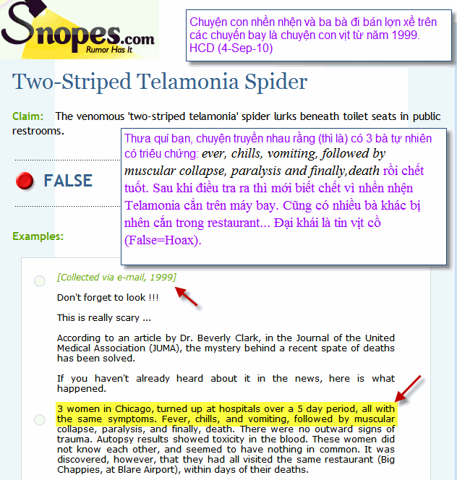

Còn nhiều con vịt đang nhốt trong lồng nơi đây:
Quán gõ đầu vịt & cú đầu "toa thuốc email" < -- click để download

Click nơi đây để vào trang điểm mặt những con vịt Việt Nam đang tung cánh la ó điếc tai mọi người, và xem điểm mặt "toa thuốc email"

Nguyên văn con vịt dưới đây:
Wonder if this is true. Well no harm to know and be careful.

Subject: Fw: Caution every one of your contacts - DON'T delay please

Please pay attention to this article. It is of utmost importance.

Three women in KL turned up at hospitals over a 5-day period,
all with the same symptoms - fever, chills, vomiting, followed by muscular collapse, paralysis and finally,death.
There were no outward signs of trauma. Autopsy results showed toxicity in the blood. These women did not know each other, and seemed to have nothing in common.

It was discovered, however, that they had all visited a same restaurant along Jalan Kuchai Lama within days of their deaths. The health department descended on the restaurant, shutting it down. The food, water and air conditioning were all inspected and tested, to no avail.

The big break came when a waitress at the restaurant was rushed to the hospital with similar symptoms. She told doctors that she had been on vacation, and had only went to the restaurant to pick up her check. She did not eat or drink while she was there, but had used the restroom.

That is when one toxicologist, remembering an article he had read, drove up to the restaurant, went into the restroom and lifted the toilet seat. Under the seat, out of normal view, was a small spider. The spider was captured and brought back to the lab,where it was determined to be the Two-Striped Telamonia (Telamonia dimidiata), so named because of its reddened flesh color. This spider's venom is extremely toxic but can take several days to take effect. They live in cold, dark, damp climates, and toilet rims provide just the right atmosphere.

Several days later, a lawyer from JB showed up at a hospital emergency room.. Before his death, he told the doctor that he had been away on business, had taken a flight from Indonesia , changing planes in Singapore , before returning home. He did not visit the restaurant while there. He did, as did all of the other victims, have what was determined to be a puncture wound, on his right buttock.

Investigators discovered that the flight he was on had originated in India .. The Civilian Aeronautics Board (CAB) ordered an immediate inspection of the toilets of all flights from India , and discovered the Two-Striped Telamonia (Telamonia dimidiata) spider's nests on four different planes!

It is now believed that these spiders can be anywhere in the country. So please, before you use a public toilet, lift the seat to check for spiders.

It can save your life! And please pass this on to everyone you care about.

P Susthitha Menon (Susi)
Photonics Technology Laboratory
Department of Electrical, Electronics and System Engineering
Universiti Kebangsaan Malaysia
( National University of Malaysia )
43600 UKM Bangi
Selangor Darul Ehsan.
-------------------------------------------

Còn nhiều con vịt đang nhốt trong lồng nơi đây:
Quán gõ đầu vịt & cú đầu "toa thuốc email" < -- click để download

Click nơi đây để vào trang điểm mặt những con vịt Việt Nam đang tung cánh la ó điếc tai mọi người, và xem điểm mặt "toa thuốc email"

